**Stock Analysis and Prediction Website Documentation**

**Introduction**

Welcome to our innovative Stock Analysis and Prediction website, where we empower users with insights into the stock market trends. This documentation provides a comprehensive overview of the website's features and functionalities.

**Home Page**

The Home Page serves as the user's initial interaction with the website. It introduces the user to the platform and provides information about the talented team behind the creation.

**Content:**

**Welcome Message:** A warm greeting to the user, inviting them to explore the world of stock analysis and prediction.

**Team Introduction:**

Brief bios and roles of the creators.

Engaging visuals, such as team photos or individual pictures.

**Mission Statement:** Clearly communicate the purpose and vision of the website.

**Login Page**

The Login Page is the gateway for users to access personalized features such as setting up their watchlist.

**Content:**

**Login Form:**

Username and password fields.

Option for new users to register.

**Registration Form:**

Essential user details (name, email, etc.).

Captcha for security.

**Dashboard**

The Dashboard provides users with a centralized hub to explore trending stocks and other relevant features.

**Content:**

**Trending Stocks Section:**

Real-time updates on stocks gaining popularity.

Visual representation (charts, graphs).

**Watchlist:**

User-specific watchlist management.

Add and remove stocks.

**Additional Features:**

News feed related to the stock market.

Quick links to other essential sections.

**Stock Details Page**

The Stock Details Page offers in-depth information about individual stocks, providing users with a comprehensive analysis.

**Content:**

**Stock Overview:**

Company name, symbol, and sector.

Real-time stock price and performance.

**Historical Data:**

Graphical representation of stock performance over time.

Key statistics (highs, lows, volumes).

**Analyst Recommendations:**

Third-party analyst insights.

**User Comments Section:**

Community engagement with user comments and discussions.

**Conclusion**

Our Stock Analysis and Prediction website aim to revolutionize the way users interact with the stock market. With a user-friendly interface and powerful features, we strive to provide valuable insights and a seamless experience for both novice and experienced investors.

Feel free to reach out if you have any specific questions or need further clarification on any aspect of the website. We look forward to presenting this exciting project officially!

**Flow Chart**

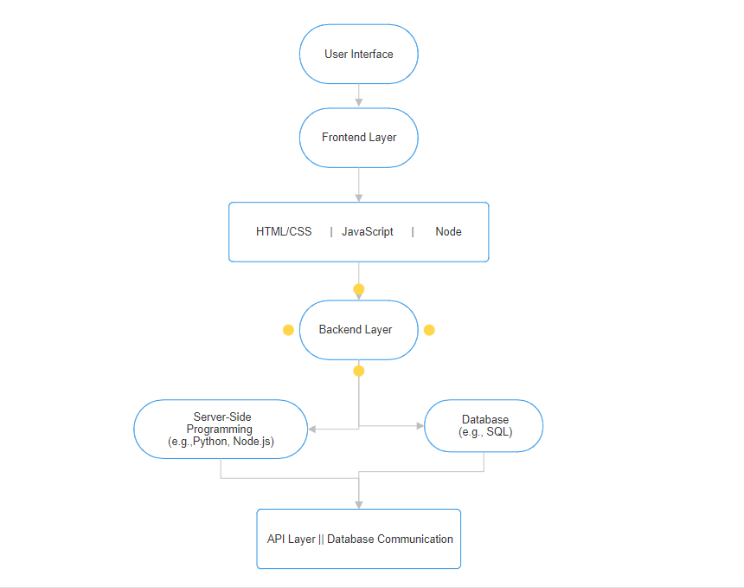

**Individual contribution : -**

**Priyanshu Kushwah - Frontend Layer (HTML/CSS/JavaScript):**

Responsible for designing and implementing the user interface of the Stock Analysis and Prediction website.

Utilized HTML for structuring web content, CSS for styling and layout, and JavaScript for interactive features.

Collaborated with Ayush Singhai to ensure a cohesive and visually appealing frontend design.

**Ayush Singhai - Frontend Layer (HTML/CSS/JavaScript):**

Worked alongside Priyanshu Kushwah in developing the frontend layer of the website.

Focused on creating responsive and user-friendly interfaces using HTML, CSS, and JavaScript.

Ensured cross-browser compatibility and a seamless user experience.

**Aditya Pal - Data and APIs:**

Managed the integration of external APIs, including financial data and news feeds, to fetch real-time information.

Implemented data processing techniques for stock analysis, incorporating machine learning and technical analysis.

Responsible for maintaining and updating the data sources to ensure accuracy and relevance.

**Himanshu Saraswat** - Logical Coding, Data Structures, and Algorithms (Backend Layer):

Took charge of the backend layer, implementing business logic, and handling data processing.

Applied data structures and algorithms for efficient data manipulation and analysis.

Ensured the scalability and performance of the backend system.

**Yojith Kaustabh** - Database (using SQL):

Designed and implemented the database schema using SQL to store user data, stock information, and other relevant data.

Implemented database communication and ensured data integrity.

Responsible for optimizing database queries to enhance overall system performance.

These roles showcase a well-distributed set of responsibilities across the team, covering both frontend and backend development, data integration, and database management. Effective collaboration among team members with specialized skills ensures a robust and feature-rich Stock Analysis and Prediction website. Regular communication and coordination among team members are crucial for the success of the project.